
ASTROSAGE ANALYSIS
PROJECT
BY
SOUPARNA MAITY
NEWTON BATCH – MAY 2025

This word file contains all the answers and suggestions for Objective and Subjective questions.

DATE – 25.JUNE.2025

The AstroSage Dataset include(Schemas) –
- _id: Unique identifier for each record.
- user: User ID associated with the record.
- chatStatus: Status of the chat (e.g., incomplete, failed, completed).
- guru: Unique identifier for the guru.
- guruName: Name of the guru.
- gid: Guru ID.
- uid: User ID.
- consultation Type: Type of consultation (e.g., Chat, Call).
- website: Source of the consultation (e.g., gurucool).
- Refund Status: Indicates if the session is refundable or not (e.g., no-refund).
- is WhiteList User: Boolean indicating if the user is whitelisted.
- chat Seconds: Duration of the chat in seconds.
- queue: Boolean indicating if the session was queued.
- FreeCall: Boolean indicating if the call was free.
- Free Chat: Boolean indicating if the chat was free.
- CreatedAT: Original creation date and time.
- updatedAt: Original update date and time.
- __v: Version key.
- statementEntryId: Identifier for the statement entry.
- chatStartTime: Start time of the chat.
- chatEndTime: End time of the chat.
- timeDuration: Duration of the session.
- callChannel: Channel used for the call.
- callIvrType: IVR type used during the call.
- callStatus: Status of the call.
- CallSid: Unique identifier for the call session.
- amount: Amount charged for the session.
- astrologerCallStatus: Status of the astrologer during the call.
- astrologerOnCallDuration: Duration of the astrologer's call.
- astrologersEarnings: Earnings of the astrologer from the session.
- netAmount: Net amount after deductions.
- region: Region of the user.
- userCallStatus: Status of the user's call.
- userOnCallDuration: Duration of the user's call.
- rating: Rating assigned based on the session's status

Objective Questions

1) What is the total no. of tables present in the data?
Ans- There is Only one table named Astrosage is present in the dataset for analysis.

2) What is the total no. of attributes present in the data?
Ans- There are total 39 attributes present in the raw datasheet for analysis. And in cleaned datasheet there are 34 attributes are present.
Function used – =CountA()

3) The data consists of some inconsistent and missing values so ensure that the data used for further analysis is cleaned.
Ans- Data has been cleaned with the help of different excel functions Aggregate functions, Logical functions, Condition aggregation, Text functions, Date functions, Lookup functions and Formating functions.
1) CHANGE OF NAMES OF COLUMNS.
1) uid – User_ID
2) gid – Guru_ID
3)guruName – Guru_Names
8) chatStatus – ChatStatus
5) consulation Type – ConsultationType
6) chatsecond – Chat_Second
7)conlutiontype – ConclusionType

Excluded Columns – ID, User, Guru, statementEntryId, chatStartTime, chatEndTime.

Included Columns – Date ,Year, Month , Time.
The Date column is Calculated using Date function.
=DATE(YEAR(M2),MONTH(M2),DAY(M2))
Year - =TEXT(O2,"YYYY")
Month - =TEXT(O2,"MMM")
Time- =TIME(HOUR(M2),MINUTE(M2),SEC(M2))

Chart Start time - =TEXT(SUBSTITUTE(SUBSTITUTE([@ChatStartTime],"T"," "), "Z", ""), "yyyy-mm-dd hh:mm:ss")
Chat end time - =TEXT(SUBSTITUTE(SUBSTITUTE([@ChatEndTime],"T"," "), "Z", ""), "yyyy-mm-dd hh:mm:ss")
Chat Duration - =IFERROR([@Column2]-[@Column1],"")

3) MISSING VALUES.

1)There was blank spaces in the column Chat Status , Chat Time , Chat date. As the blank spaces shows the call service taken, so the missing values in this columns are filled with “Call option used.”
2)There was blank spaces in the column Call Status ,As the blank spaces shows the chat service taken, so the missing values in this columns are filled with “Call”.
3) There was blank spaces in the column Call Second ,As the blank spaces shows the chat service taken, so the missing values in this columns are filled with “0”.
The missing Value of cells is calculated using Logical Operation.
IF(ISBLANK(cell_reference), value_if_blank, value_if_not_blank)

4) COLOUR FORMATTING.
Home tab -> Styles -> Conditional Formatting -> Highlight cells rule -> Test that contain -> Write text and choose colour. (This will help to highlight the texts)
- In the Consultation Type, Chat Status, Chat seconds, column the “Chat” text is formatted in yellow colour while “Call” text in Dark yellow.

4) What is the average daily call volume over the day by day and what’s the change on it?
Answer: Average Daily Calls – 246.03
The average number of calls is calculated using the aggregate function AVERAGE() in a PivotTable, where the rows are set to Date and the values represent the Count of CallsID. By applying the AVERAGE() function to the count of CallsID, we obtain the average number of calls per day.

Date | COUNTA of CallSid | Percentage Change
01-12-2023 | 228 | First data point
02-12-2023 | 332 | 31.33%
03-12-2023 | 383 | 13.32%
04-12-2023 | 364 | -5.22%
05-12-2023 | 253 | -43.87%
06-12-2023 | 254 | 0.39%
07-12-2023 | 254 | 0.00%
08-12-2023 | 138 | -84.06%
09-12-2023 | 288 | 52.08%
10-12-2023 | 430 | 33.02%
11-12-2023 | 424 | -1.42%
12-12-2023 | 358 | -18.44%
13-12-2023 | 348 | -2.87%
14-12-2023 | 226 | -53.98%
15-12-2023 | 276 | 18.12%
16-12-2023 | 258 | -6.98%
17-12-2023 | 185 | -39.46%
18-12-2023 | 233 | 20.60%
19-12-2023 | 209 | -11.48%
20-12-2023 | 178 | -17.42%
21-12-2023 | 159 | -11.95%
22-12-2023 | 163 | 2.45%
23-12-2023 | 241 | 32.37%
24-12-2023 | 232 | -3.88%
25-12-2023 | 258 | 10.08%
26-12-2023 | 255 | -1.18%
27-12-2023 | 242 | -5.37%
28-12-2023 | 181 | -33.70%
29-12-2023 | 260 | 30.38%
30-12-2023 | 179 | -45.25%
31-12-2023 | 158 | -13.29%
01-01-2024 | 115 | -37.39%
02-01-2024 | 196 | 41.33%
03-01-2024 | 107 | -83.18%
Grand Total | 8365

The formula =AVERAGE(B4:B37) is used to calculate the average number of calls in the day-by-day PivotTable. To analyze daily percentage changes, a basic calculation is performed by dividing the current day's value by the previous day's value. Conditional formatting is applied to visually highlight significant variations. Notably, on 03/01/2024, the call volume experienced a significant decrease of -83.18%, marking the steepest drop observed during the months of December and January

The graph illustrates daily call volumes, revealing a downward trend in average call volume over time.

5) Which months experienced the highest and lowest call volumes?
Ans-There are only 34 days are given which is of only two months December and January. 31 days of December and only 3 days of January.
On 10/12/23 there was highest call volume i.e 386.
Formula used- =Max(call volume column)
On 03/01/2024 there was lowest call volume i.e. 63.
Formula used - =Min(call volume column)
December – Highest call volume.
January – Lowest call volume.

6) What is the total operational cost for that month?
Ans –The operational cost for that month= Total net income of month – Astrologer income of month.
- December :
Astrologer Earnings – 93786.16
Function Used – SUMIF(Data!P:P,"Dec",Data!AF:AF)
Net Earning – 202214.63
Function used – SUMIF(Data!P:P,"Dec",Data!AG:AG)
Operation Cost – 108428.46
Function used – (E7-E5)
December Operation Cost – 108428.46

- January :
Astrologer Earnings –5360.41
Function Used – SUMIF(Data!P:P,"Jan",Data!AF:AF)
Net Earning – 11773
Function used – SUMIF(Data!P:P,"Jan",Data!AG:AG)
Operation Cost –6412.28
Function used – (I7-I5)
January Operation Cost – 6412.28

7) What is the average number of calls handled per agent per day?
Ans –
Total Calls – 8508
Function Used- =COUNTIF(Data!F:F,Data!$F$9)
Number of days – 34
Function Used –
IFERROR(__xludf.DUMMYFUNCTION("COUNT(UNIQUE(data!R2:R28028))"),34)
Number of agents(Guru)- 131
Function used - =COUNT(UNIQUE(Data!B:B))

First we have to find average number of calls per day.
Average number of calls per day= Total calls / Number of days
= 5808 / 34
= 250.23
Now we have to find average number of calls handled by per agent per day.
Average number of calls handled by per agent per day = Average number of calls per day / Number of Agent
= 250.23 / 131
= 1.91
So we can say that approx. 2 calls are handled by per person per day.

8) How many repeat callers are there, and what percentage of total calls do they represent?
Repeat Caller Analysis
To identify repeat callers, a PivotTable was created using user_id as the row label and CallsID as the values.
Total callers: 3,426 (derived from the count of row labels in the PivotTable)
Total unique callers: Calculated using the formula =COUNTIF(C8:C3433,"=1"), resulting in 2,325
Repeat callers: 1,101 (difference between total callers and unique callers)
Total number of calls: 7,325
Calls made by repeat callers: 5,000
First calls made by repeat callers (excluded from repeat call percentage): 1,099
Percentage of total calls made by repeat callers: 53.26%

Note: Only successful calls were considered in this analysis; calls with a ‘Failed’ status were excluded.

Total Unique Callers | 2325
Total Callers | 3426
Repeat Callers | 1101
Total Calls | 7325
Calls Done By Repeat Callers | 5000
Total first Calls of Repeat Callers | 1099
Calls Considered for repeat calls | 3901
% of Total calls repeat callers represent | 53.26%

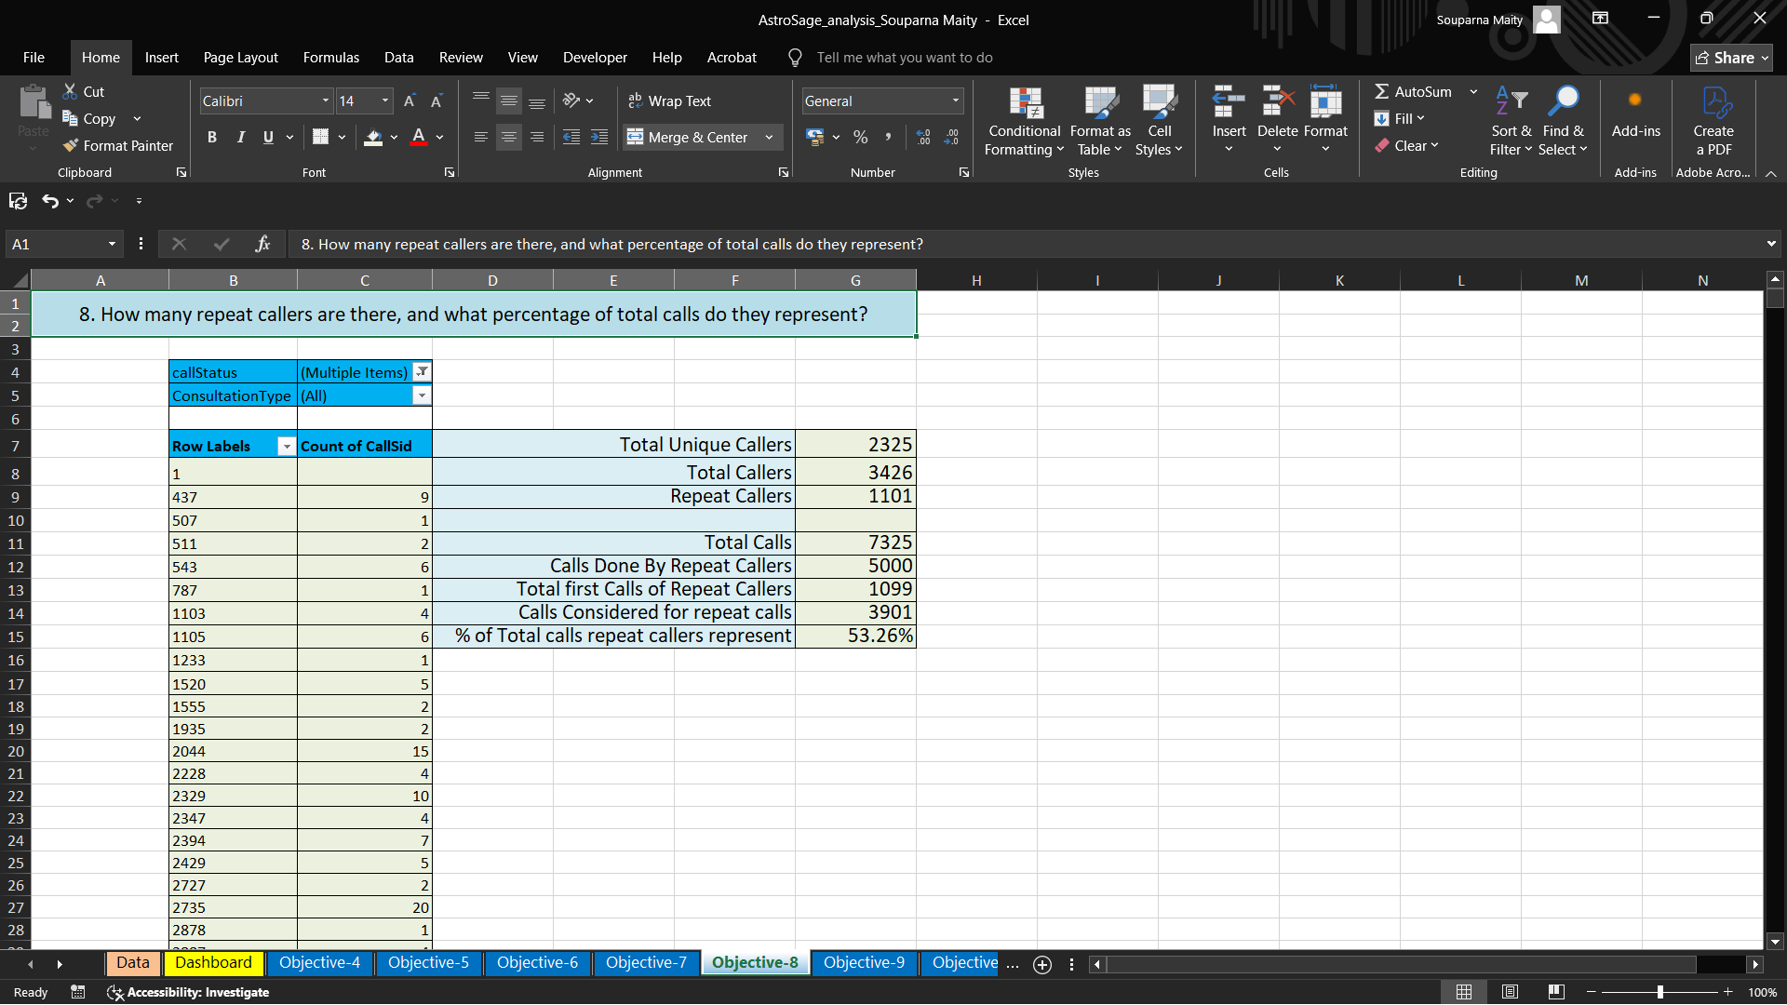

9) What is the total sales generated by the call centre for each product category?
Row Labels | Sum of netAmount
app | 125267.382
dashboard
gurucool | 88719.93333
Grand Total | 213987.3153

Ans- Website (Source of consultation ) taken as the product categories.
Highest sales generated by App. And lowest by Dashboard.

10) How many calls were made for each user ID and guru ID?
Answer:
To determine the number of calls made for each User ID and Guru ID, a PivotTable was created using the dataset.

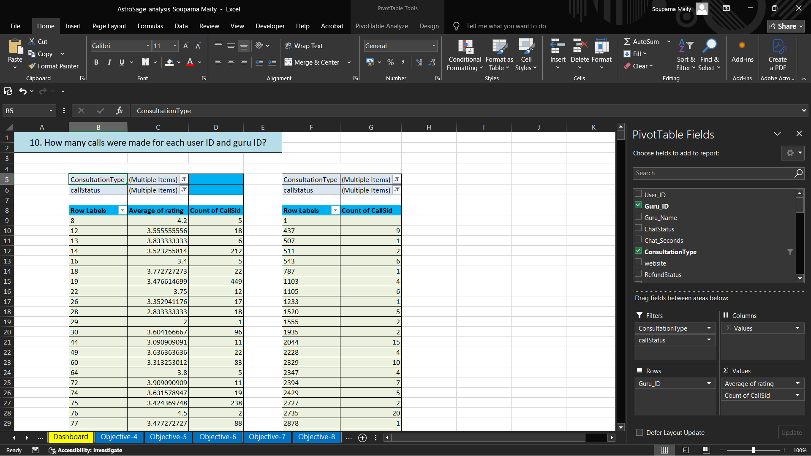
The steps followed were:
Insert a PivotTable from the main dataset.
Rows:
First, select User ID to view calls per user.
Then, separately, use Guru ID to view calls per guru.
Values:
Use CallsID and set the aggregation function to Count.
This process results in two separate summaries:
Total Calls per User ID - 8365
Total Calls per Guru ID - 7325
These summaries show how many times each user or guru was involved in a call.
Note: Calls with a ‘Failed’ status were excluded to ensure only successful interactions were counted.
The list is very long as there 3629 users who used call service and they made 8508 calls in total.
Formula used- =COUNTIF() (To measure total calls )
=COUNT() (To measure users)
With the help help of pivot table we can see the calls made for each User ID and Guru ID.
There are 131 Gurus who received calls from users.

11) What is the correlation between call duration and customer satisfaction?
Answer:
To analyze the correlation between call duration and customer satisfaction, the following steps were performed:
Data Preparation:
Extracted relevant columns: Call Duration and Customer Satisfaction Score or rating.
Removed any rows with missing or invalid values.
Analysis Method:
Used the CORREL() function in Excel:
=CORREL(C8:C241,D8:D241)
where range1 is the column for satisfaction scores and range2 is the column for call duration.
Result:
The resulting correlation coefficient was 0.018183448.
A value close to:
+1 indicates a strong positive correlation.
0 indicates no correlation.
-1 indicates a strong negative correlation.

12) Which guru have the highest and lowest customer satisfaction scores?

To identify the gurus with the highest and lowest customer satisfaction scores, the following steps were taken:
Highest
Row Labels | RatingAVG
Astro Pujaa Rai | 7.5
97 | 7.5
Tarot Mystical | 7.5
305 | 7.5
Daljit Kaur | 5.9
277 | 5.9
Astro Reema | 5.9
286 | 5.9
Tarot Ankita | 5.8
289 | 5.8
Astro Saraswat | 5.6
312 | 5.6
Tarot Diva Poonam | 5.5
309 | 5.5
Astro Trisha | 5.4
302 | 5.4
Tarot Oormika | 5.4
304 | 5.4
Astro Manish S | 5.0
253 | 5.0
Tarrot Ria | 5.0
282 | 5.0
Swami Chandreshwaranand��G | 5.0
13 | 5.0
Vandana Bhutani | 5.0
27 | 5.0

Lowest
Row Labels | RatingAVG
Tarot Rittika | 0.0
80 | 0.0
Astro K Ojha | 0.1
219 | 0.1
Acharya Divyansh | 0.4
250 | 0.4
Astro Aditya | 0.8
307 | 0.8
Astro Sushil S | 0.9
323 | 0.9
Tarot Punam | 0.9
310 | 0.9
Astro Chandan | 1.0
270 | 1.0
Astro Yogendra | 1.0
201 | 1.0
Tarot Ittishri | 1.2
316 | 1.2
Tarot Keshmin | 1.2
298 | 1.2
Dr. Harish | 1.3
220 | 1.3
Gurucool Support | 1.4
214 | 1.4
Tarot Supriya Suri | 1.5
132 | 1.5
Astro R J S | 1.5
324 | 1.5
Astro Rohan S | 1.5
29 | 1.5

PivotTable Creation:
Rows: Guru ID
Values: Average of Customer Satisfaction Score or rating
Sorting:
The PivotTable was sorted in descending order to identify the guru with the highest score and in ascending order for the lowest.
Result:
Guru with Highest Satisfaction Score: [Guru ID] — Score: 7.5
Guru with Lowest Satisfaction Score: [Guru ID] — Score: 0

Note: Only valid (non-empty and non-failed) satisfaction scores were considered in this analysis.

 |  | Rating | Guru
Highest Customer Satisfaction |  | 7.5 | 305
 |  | 7.5 | Tarot Mystical
Lowest Customer Satisfaction |  | 0 | 80
 |  | 0 | Tarot Rittika

13) What is the average customer satisfaction score by month?
Answer:

To calculate the average customer satisfaction score by month, the following steps were performed:
Data Preparation:
Extracted the Date and Customer Satisfaction Score columns.
Converted the date field to display only the month and year (e.g., using =DATE(YEAR(M2),MONTH(M2),DAY(M2))
PivotTable Setup:
Rows: Month (formatted as "MMM YYYY")
Values: Average of Customer Satisfaction Score
Result:
The PivotTable shows the monthly average satisfaction scores.
Example:
December 2023: 2.95
January 2024: 2.68
Interpretation:
This analysis helps in understanding trends or fluctuations in customer satisfaction over time.
Note: Entries with missing or invalid satisfaction scores were excluded from the calculation.

14) How many categorical columns are there in the data? [Search about
categorical and continuous data, and try to answer this question]
Answer:
1) Categorical Columns:
Definition: These are variables that represent distinct categories or groups. The values are typically qualitative and can be divided into discrete, non-numeric groups or labels.
Categorical columns are:(From raw dataset)
_id CallSid
user, astrologerCallStatus
chatStatus region
guru userCallStatus
guruName gid
uid callStatus
consultationType callIvrType
website FreeChat
RefundStatus callChannel
isWhiteListUser FreeCall
queue
They are categorical columns because the show characteristics like –
Qualitative: They represent descriptive characteristics or labels.
Discrete: There is a limited or fixed number of values.
Non-numeric: Though some categorical variables can be numeric (like ID numbers), the numbers don't have mathematical meaning.
2) Continuous Columns:
Definition: These are variables that can take on any value within a certain range and are typically numeric. They represent measurable quantities.
Continuous Columns are : (From raw data)
chatSeconds timeDuration
amount astrologerOnCallDuration
astrologersEarnings netAmoun
userOnCallDuration rating
They are Continuous columns because the show characteristics like –
Quantitative: The data can be measured and expressed numerically.
Continuous: They can take any value within a range, including decimals.
Mathematically meaningful: You can apply arithmetic operations like addition and subtraction to continuous data.

Subjective Question

1) Should the investment be used to hire more agents, improve training
programs, or upgrade call center technology?
Answer:
1. Hiring more agents :
There are 131 Gurus, who provide service to the users.
Total call receive = 8508
Date | COUNTA of CallSid | Percentage Change
01-12-2023 | 228 | First data point
02-12-2023 | 332 | 31.33%
03-12-2023 | 383 | 13.32%
04-12-2023 | 364 | -5.22%
05-12-2023 | 253 | -43.87%
06-12-2023 | 254 | 0.39%
07-12-2023 | 254 | 0.00%
08-12-2023 | 138 | -84.06%
09-12-2023 | 288 | 52.08%
10-12-2023 | 430 | 33.02%
11-12-2023 | 424 | -1.42%
12-12-2023 | 358 | -18.44%
13-12-2023 | 348 | -2.87%
14-12-2023 | 226 | -53.98%
15-12-2023 | 276 | 18.12%
16-12-2023 | 258 | -6.98%
17-12-2023 | 185 | -39.46%
18-12-2023 | 233 | 20.60%
19-12-2023 | 209 | -11.48%
20-12-2023 | 178 | -17.42%
21-12-2023 | 159 | -11.95%
22-12-2023 | 163 | 2.45%
23-12-2023 | 241 | 32.37%
24-12-2023 | 232 | -3.88%
25-12-2023 | 258 | 10.08%
26-12-2023 | 255 | -1.18%
27-12-2023 | 242 | -5.37%
28-12-2023 | 181 | -33.70%
29-12-2023 | 260 | 30.38%
30-12-2023 | 179 | -45.25%
31-12-2023 | 158 | -13.29%
01-01-2024 | 115 | -37.39%
02-01-2024 | 196 | 41.33%
03-01-2024 | 107 | -83.18%
Grand Total | 8365

Average number of calls per day = 250 (Formula - =AVERAGE())
Row Labels | Count of astrologerCallStatus
busy | 1270
completed | 3451
failed | 1043
no-answer | 1729
Grand Total | 7493

Percentage of calls gets complete = 46.06 % {Formula= (Completed calls * 100)/ total calls}
Call centre receive approx. 250 calls per day but only 46.06% of calls gets complete in total. There is a need of investment in the hiring of agents to manage the workload.

While hiring can help distribute the workload, the data shows that not all agents are fully utilized throughout the day. Many calls come in during peak hours (mainly 5 AM to 5 PM), but outside that window, activity drops. So bringing in more agents might lead to underutilization and higher costs.
Better approach: Instead of hiring in bulk, we can identify specific time slots or skill gaps where a few new hires might make a difference.

2. Training :
Only 27.49% of users are satisfied with the service.
Total users = 28027
Satisfied user (Rating-5,6,7,8) = 27.49 %
(formula- =(SUM(satisfied users)*100/total users))
Unsatisfied user (Rating-0,1,2,3,4) = 72.51 %
rating | COUNTA of gid
0 | 7256
1 | 2199
2 | 4329
3 | 4407
4 | 2132
5 | 2169
6 | 1829
7 | 1824
8 | 1882
Grand Total | 28027

I think the investment should be used to improve training program. There are three reasons.
REASON 1 -
The total call duration of Astrologer is 1077344 sec (299.26 hours).
The total call duration of user is 993635 sec (276.0097 hours).
The difference is of 83709 sec (23.25 hours )
This suggest that Astrologer taking more time to handle calls, which indicating the need for improvement in efficiency.
(Formula use to calculate call duration is =Sum function)

REASON 2 -
Out of 8541 calls only 3453 calls are getting completed, which is 40.43 %.
That means 59.57 % of users are not getting the service despite of booking the call session.
It is one of the reasons why the average rating of the call service is 3.50 only.
[Formula used - =AVERAGEIF(Data!F:F,Data!$F$9,Data!AH:AH)]
Row Labels | Count of astrologerCallStatus
busy | 1270
completed | 3451
failed | 1043
incomplete | 875
no-answer | 1729
Grand Total | 8368

Call completed =3451
Other status(Busy, failed, incomplete, no answer) =4917
Percent of completed calls = (Completed calls * 100) / Total calls
= (3451*100)/8368
= 41.24 %
Percent of incomplete calls (other status) = 58.75%.
REASON 3-
The 78.72% of the total net income for the company comes from Call service only.
And the 78.46% of the total income for the astrologer comes from Call service.
So if the call service is a key revenue driver, investing in training programs would be a strategic move to sustain and enhance that success.

Row Labels | Sum of astrologersEarnings | Sum of netAmount
Call | 77799.43983 | 168442.035
Chat | 21338.6415 | 45494.68333
Complementary
public_live_Call | 8.489616667 | 50.597
Grand Total | 99146.57095 | 213987.3153

Percent of call income = (Call income * 100)/Total income
3. Upgrading Technology :
 | Average of rating
app | 3.5
dashboard | 4.5
gurucool | 2.716440049
Grand Total | 2.93463446

Row Labels | Count of User_ID
Call | 8508
Chat | 19514
Complementary | 2
public_live_Call | 3
Grand Total | 28027

Row Labels | Sum of User_ID
app | 258555794
dashboard | 22478
gurucool | 718060178
Grand Total | 976638450

There is need for technology upgrades because 69.62% of total users use chat service. And Gurucool is only one platform which provide the service of the Chat to the users. But the average rating of the Gurucool is 2.71, which is the clear indicator of unsatisfied users. So it is very necessary to improve technology and provide satisfaction to the users . Investing in technology upgrades will help to improve the overall experience and will help to increase the retention rate of the users. But there are some risks in upgrading technology.

Final Recommendation :
I'd suggest:
- 40% on training – we get quicker wins by upskilling the current team
- 40% on tech upgrades – it makes the entire process more efficient
- 20% on hiring – selectively add agents only where needed, like peak shifts or specific skill gaps
This way, we get better results without overspending.

2) What are the potential risks of each investment option (hiring, training,
technology upgrades), and how can they be mitigated?
Name the chart/spreadsheet function you will use for solving the problem?
Answer:
1. Hiring
Potential Risks:

- High Initial Costs: Recruiting skilled agents with broad expertise (e.g., in Astrology) can involve significant upfront expenses.
- Adaptation Time: New hires may require time to align with the company’s operational pace, which may delay returns.
Mitigation Strategies:
- Focus on hiring adaptable, mid-level professionals who demonstrate high potential and enthusiasm.
- Align employee and organizational goals through onboarding and structured training to accelerate integration and motivation.

2. Training
Potential Risks:

- Cost of Training Programs: Expert-level training can temporarily reduce productivity and increase operational costs.
- Employee Attrition Post-Training: Trained employees might seek better opportunities, leading to talent loss.
Mitigation Strategies:
- Monitor training effectiveness and gather regular feedback to optimize content and delivery.
- Offer incentives such as recognition programs and retention bonuses to maintain employee loyalty post-training.

3. Technology Upgrades

Potential Risks:

- Implementation Challenges: New technologies can introduce unforeseen bugs or technical issues during deployment.
- Long-Term Cost: Licensing, maintenance, and upgrade cycles may significantly affect the long-term budget.
Mitigation Strategies:
- Adopt a phased implementation strategy to identify and resolve issues at each stage.
- Conduct ROI (Return on Investment) assessments before deployment to ensure financial feasibility and effective budget allocation.

Spreadsheet Functions/Tools for Risk Analysis:

- What-If Analysis: Tools like Goal Seek and Scenario Manager can simulate various outcomes and assess the financial implications of each investment decision.
Forecasting: Excel’s Forecast Sheet function can be used to predict future ROI and resource requirements, aiding in strategic planning and risk mitigation.

3) How does AstroSage call center performance compare to that of AstroGuru in
terms of average call volume, customer satisfaction, and agent performance?
Will you use any aggregation function or a visualization here to solve the
problem?
Date | COUNTA of CallSid | Percentage Change
01-12-2023 | 228 | First data point
02-12-2023 | 332 | 31.33%
03-12-2023 | 383 | 13.32%
04-12-2023 | 364 | -5.22%
05-12-2023 | 253 | -43.87%
06-12-2023 | 254 | 0.39%
07-12-2023 | 254 | 0.00%
08-12-2023 | 138 | -84.06%
09-12-2023 | 288 | 52.08%
10-12-2023 | 430 | 33.02%
11-12-2023 | 424 | -1.42%
12-12-2023 | 358 | -18.44%
13-12-2023 | 348 | -2.87%
14-12-2023 | 226 | -53.98%
15-12-2023 | 276 | 18.12%
16-12-2023 | 258 | -6.98%
17-12-2023 | 185 | -39.46%
18-12-2023 | 233 | 20.60%
19-12-2023 | 209 | -11.48%
20-12-2023 | 178 | -17.42%
21-12-2023 | 159 | -11.95%
22-12-2023 | 163 | 2.45%
23-12-2023 | 241 | 32.37%
24-12-2023 | 232 | -3.88%
25-12-2023 | 258 | 10.08%
26-12-2023 | 255 | -1.18%
27-12-2023 | 242 | -5.37%
28-12-2023 | 181 | -33.70%
29-12-2023 | 260 | 30.38%
30-12-2023 | 179 | -45.25%
31-12-2023 | 158 | -13.29%
01-01-2024 | 115 | -37.39%
02-01-2024 | 196 | 41.33%
03-01-2024 | 107 | -83.18%
Grand Total | 8365

The average call volume per day is 246 calls .
There are 131 gurus who can receive calls.
But out of 8541 total calls only 3453 calls are getting completed, which is 40.43 %.
That means 59.57 % of users are not getting the service despite of booking the call session. This is the reason why the average rating of the call service is 3.5 only.
Row Labels | Count of ConsultationType | Average of rating
Call | 8508 | 3.50
Chat | 19514 | 2.69
Complementary | 2 | 4.50
public_live_Call | 3 | 3.00
Grand Total | 28027 | 2.93

If the rating of the Astrologers increase then company rating also increase.

The 78.72% of the total net income for the company comes from Call service only.
And the 78.46% of the total income for the astrologer comes from Call service.
So if the call service is a key revenue driver, investing in training programs would be a strategic move to sustain and enhance that success.
Row Labels | Sum of astrologersEarnings | Sum of netAmount
Call | 77799.43983 | 168442.035
Chat | 21338.6415 | 45494.68333
Complementary
public_live_Call | 8.489616667 | 50.597
Grand Total | 99146.57095 | 213987.3153

Percent of call income = (Call income * 100)/Total income

The performance of agents are very important to the company as they are interconnected. Because there is the correlation to the agent earning and net amount.
Correlation of agent earning and net amount= 0.9970
(Formula - =CORREL())
A correlation of 0.99 suggests a very strong positive linear relationship between two variables. This means that as one variable increases, the other variable almost always increases in a nearly predictable manner. The closer the correlation coefficient (r) is to 1, the stronger the relationship, with 1 representing a perfect positive correlation.

Row Labels | Sum of astrologersEarnings | Sum of netAmount
01-12-2023 | 2653.458333 | 5518.783333
02-12-2023 | 1487.243333 | 3170.316667
03-12-2023 | 1324.933333 | 2762.05
04-12-2023 | 3887.303333 | 7808
05-12-2023 | 2201.091667 | 4619.55
06-12-2023 | 2443.79 | 5296.033333
07-12-2023 | 3721.033333 | 7826.75
08-12-2023 | 2234.465 | 4664.633333
09-12-2023 | 2544.695 | 5189.05
10-12-2023 | 3292.658333 | 7049.166667
11-12-2023 | 2507.973333 | 5493.183333
12-12-2023 | 1645.216667 | 3593.433333
13-12-2023 | 2559.925667 | 5603.56
14-12-2023 | 2908.661 | 6951.015
15-12-2023 | 5547.338 | 11884.57833
16-12-2023 | 5060.172833 | 11107.48333
17-12-2023 | 3252.140667 | 6983.001667
18-12-2023 | 2090.159333 | 4580.298333
19-12-2023 | 5963.262667 | 12970.29
20-12-2023 | 4821.973117 | 10530.53117
21-12-2023 | 2333.079833 | 5134.365833
22-12-2023 | 2933.722667 | 6515.49
23-12-2023 | 2685.864 | 5988.343333
24-12-2023 | 4097.367333 | 8666.098333
25-12-2023 | 4107.5995 | 8904.938333
26-12-2023 | 2954.215 | 6505.8
27-12-2023 | 4136.948667 | 9021.213333
28-12-2023 | 2410.069667 | 5334.398333
29-12-2023 | 1425.4 | 3055.033333
30-12-2023 | 2681.3 | 5695.816667
31-12-2023 | 1873.101333 | 3791.42
01-01-2024 | 1762.291 | 3911.715
02-01-2024 | 1610.584 | 3513.343333
03-01-2024 | 1987.533 | 4347.631667
Grand Total | 99146.57095 | 213987.3153

4) How can the call center improve its handling of peak call periods to ensure
high customer satisfaction?
Mention the functionality which you will use for giving the suggestions, will it
be any aggregated function or a visualization?
Analysis:
- Upon analyzing the dataset, it was observed that the majority of calls — 5,851 calls, accounting for approximately 79.88% of the total volume — were made between 5:00 AM and 5:00 PM.
- This insight was obtained using a Pivot Table that grouped call data on an hourly basis, and a Column Chart was generated to visually analyze the call distribution across the day.

- Findings:
- Peak Hours Identified: 5:00 AM to 5:00 PM
- Call Volume during Peak Hours: 5,851
- Percentage of Total Calls: 79.88%

- Recommendations:

- Optimized Shift Scheduling:
- Allocate 80% of available agents during the peak hours (5 AM – 5 PM) to effectively manage high call volumes.
- Assign the remaining 20% of agents to off-peak hours, where the call load is significantly lower.

- Benefits of Redistribution:
- Prevents agent burnout by aligning resources with demand.
- Reduces customer wait time and improves call resolution rates.
- Enhances overall customer satisfaction and service consistency.

- Excel Tools Used:

- Pivot Table: To group and aggregate calls by hour
- Column Chart: To visualize hourly call volume distribution
- Basic Aggregation Functions: Such as COUNTIFS(), to quantify calls within specific time intervals, SUM(), for Call Volume during Peak and Percentage of Total Calls.

Date 2023-12-10 and 2023-12-11 receive the highest calls

On 2023-12-10 and 2023-12-11 receive the highest calls, but only 65.3 % users get the service while other 34.73 % got the call of astrologer busy or there call got cancel as the astrologer was busy.
Row Labels | Count of astrologerCallStatus
busy | 161
completed | 296
failed | 105
incomplete | 115
no-answer | 177
Grand Total | 854

Method - Completed call % = (Completed calls * 100)/ total calls
And Creating a pivot Table by adding callstatus in row, count of astrologerscallstatus as Value and Add date on filter.
Suggestions-
1) So to come over this the company can start the option of live streaming model to engage users in live session and improve the handling of the crowd that comes in peak times. Live streaming will also bring revenue and more user to the company.
2) Shift optimization- Optimizing more agents shifts to peak periods accordingly. Ensure that more agents are scheduled during high – traffics time.
3) Use part time or freelancer agents , this reserve agents will balance the workload without increasing permanent cost.

5) Based on historical data, what strategic initiatives should be prioritized to
improve overall efficiency and customer satisfaction?

Ans – The following strategies can help –
STATEGY 1- Training programs
Only 27.49% of users are satisfied with the service.
Total users = 28027
Satisfied user (Rating-5,6,7,8) = 27.49 %
(formula- =(SUM(satisfied users)*100/total users))
Unsatisfied user (Rating-0,1,2,3,4) = 72.51 %
rating | COUNTA of gid
0 | 7256
1 | 2199
2 | 4329
3 | 4407
4 | 2132
5 | 2169
6 | 1829
7 | 1824
8 | 1882
Grand Total | 28027

TRAINING PROGRAM-
1) Call Handling Techniques: Train the astrologer on more efficient call-handling techniques to reduce the duration of calls without compromising the quality of service.
2) Enhancing Skills: Training can improve the skills of employees involved in the call service, leading to better customer interactions.
3) Cross-Selling: Training programs can teach employees techniques to upsell or cross-sell other services or products during calls, maximizing revenue from each interaction.
4) Adaptation to Growth: As the service grows, the company might need to scale up operations. Training helps employees adapt to new processes, tools, or technologies that support growth.
STRATEGY 2 – Upgrade Technology
Row Labels | Average of rating
app | 3.5
dashboard | 4.5
gurucool | 2.716440049
Grand Total | 2.93463446
Row Labels | Count of User_ID
Call | 8508
Chat | 19514
Complementary | 2
public_live_Call | 3
Grand Total | 28027
Row Labels | Sum of User_ID
app | 258555794
dashboard | 22478
gurucool | 718060178
Grand Total | 976638450

There is need for technology upgrades because 69.62% of total users use chat service. And Gurucool is only one platform which provide the service of the Chat to the users. But the average rating of the Gurucool is 2.71, which is the clear indicator of unsatisfied users. So it is very necessary to improve technology and provide satisfaction to the users . Investing in technology upgrades will help to improve the overall experience and will help to increase the retention rate of the users. But there are some risks in upgrading technology. Upgrading technology will help the smooth experience of providing service as well as user receiving service.

Recommended Strategic Actions:
To address these issues and improve overall service quality, the following targeted training programs are proposed:
1. Communication Skills Development
- Focus: Clarity, professionalism, empathy, and customer engagement.
- Outcome: Smoother customer interactions and improved rapport-building.
2. Problem-Solving Training
- Focus: Equipping agents to resolve queries efficiently and independently.
- Outcome: Reduced call duration and higher first-call resolution rates.
3. Technical Proficiency Enhancement
- Focus: Training on system usage, processes, and domain knowledge.
Outcome: Increased agent confidence and reduced technical escalations.
Post-Training Evaluation Strategy:

- To assess the effectiveness of the interventions, a set of Key Performance Indicators (KPIs) should be monitored:
- KPI | - Purpose
- Change in Failure Rate | - Identify performance improvement in interactions
- Customer Satisfaction Rating | - Measure change in user feedback post-training
- Call Resolution Time | - Evaluate efficiency in query resolution
- First Call Resolution Rate | - Track success in resolving issues in one call

Conclusion:
By implementing these focused interventions and tracking performance outcomes through structured KPIs, the call center can significantly enhance agent productivity, customer satisfaction, and overall service efficiency.
6) What can be the key factors contributing to high customer satisfaction scores,
and how can these be leveraged to improve overall performance?
What is the basis for the suggestions? And mention how did you decide if the
satisfaction score affect the ratings?
Answer - 69.62 % of total users use chat service.

Row Labels | Count of User_ID
Call | 8508
Chat | 19514
Complementary | 2
public_live_Call | 3
Grand Total | 28027

% of user using chat = (Chat user*100)/ Total user
Rating of 6,7,8 is consider as the high satisfaction range.

Count of User_ID | Column Labels
Row Labels | Call | Chat | Grand Total
5 | 2144 | 24 | 2168
6 |  | 1829 | 1829
7 |  | 1824 | 1824
8 |  | 1882 | 1882
Grand Total | 2144 | 5559 | 7703

Only chat service receive the rating of 6,7,8.
As 69.62% of total user use chat service and 100% of high satisfaction score is given by chat user only, then Chat service can be consider as the key factor contributing to high satisfaction score.
Method – create a pivot table by adding ratings in a row and filter 5,6,7,8, and add consulationType in column filter Call and Chat, and add Countof UserID as value.
IMPROVEMENT-
Company can improve the users experience by adding features like AI chat bots and training there employees to adapt to new processes, tools, or technologies that support growth. This will help the company to improve overall performance.
Key Contributing Factors:
1. Interaction with Expert Agents
- Observation: Agents with higher expertise and strong customer demand consistently achieve higher satisfaction scores.
- Rationale: Customers perceive expert agents as more knowledgeable and trustworthy, leading to greater satisfaction.
2. Lower Call Volume per Agent
- Observation: Agents managing fewer calls per day tend to deliver higher-quality consultations.
- Rationale: Reduced workload allows agents to dedicate more time and attention to each customer, enhancing service quality. Conversely, overburdened agents demonstrate lower efficiency, often resulting in poorer customer experiences and lower ratings.

Performance Improvement Strategy:

To enhance overall customer satisfaction and operational efficiency, the following steps are recommended:
- Redistribute Interaction Load:
  - Balance customer interactions across agents to prevent overload.
  - Assign high-value or complex queries to top-performing agents with proven expertise.
- Maintain Optimal Call Volume:
  - Limit the number of daily interactions for each agent to ensure quality is prioritized over quantity.
- Upskill Underperforming Agents:
  - Identify agents with lower satisfaction scores and provide targeted training based on skill gaps (e.g., communication, technical knowledge, or product understanding).

Basis for Analysis:

- Pivot Tables: Used to aggregate average customer ratings per agent and analyze call volume distribution.
- Agent Ranking:
  - Top Section: Highlights high-performing agents with high call volumes and above-average satisfaction scores.
  - Bottom Section: Reflects agents with low satisfaction ratings, often correlated with excessive call volume or lower expertise.

Strategic Recommendation:

- A balanced distribution of interactions, aligned with agent expertise and workload capacity, can significantly improve both individual agent performance and the overall customer experience. Prioritizing customer-agent matching based on consultation needs will foster stronger satisfaction outcomes and higher operational efficiency.
7) How should the call center balance the workload among agents to ensure optimal performance and avoid burnout?
Mention your approach and spreadsheet function for the answer?
Answer – Total call receive = 8365
Date | COUNTA of CallSid | Percentage Change
01-12-2023 | 228 | First data point
02-12-2023 | 332 | 31.33%
03-12-2023 | 383 | 13.32%
04-12-2023 | 364 | -5.22%
05-12-2023 | 253 | -43.87%
06-12-2023 | 254 | 0.39%
07-12-2023 | 254 | 0.00%
08-12-2023 | 138 | -84.06%
09-12-2023 | 288 | 52.08%
10-12-2023 | 430 | 33.02%
11-12-2023 | 424 | -1.42%
12-12-2023 | 358 | -18.44%
13-12-2023 | 348 | -2.87%
14-12-2023 | 226 | -53.98%
15-12-2023 | 276 | 18.12%
16-12-2023 | 258 | -6.98%
17-12-2023 | 185 | -39.46%
18-12-2023 | 233 | 20.60%
19-12-2023 | 209 | -11.48%
20-12-2023 | 178 | -17.42%
21-12-2023 | 159 | -11.95%
22-12-2023 | 163 | 2.45%
23-12-2023 | 241 | 32.37%
24-12-2023 | 232 | -3.88%
25-12-2023 | 258 | 10.08%
26-12-2023 | 255 | -1.18%
27-12-2023 | 242 | -5.37%
28-12-2023 | 181 | -33.70%
29-12-2023 | 260 | 30.38%
30-12-2023 | 179 | -45.25%
31-12-2023 | 158 | -13.29%
01-01-2024 | 115 | -37.39%
02-01-2024 | 196 | 41.33%
03-01-2024 | 107 | -83.18%
Grand Total | 8365

Average number of calls per day = 246 [Formula - =AVERAGE()]
Row Labels | Count of astrologerCallStatus
busy | 1270
completed | 3451
failed | 1043
no-answer | 1729
Grand Total | 7493

Percentage of calls gets complete = 46.06 % {Formula= (Completed calls * 100)/ total calls}
Call centre receive approx. 250 calls per day but only 46.06% of calls gets complete in total. There is a need of investment in the hiring of agents to manage the workload.

While hiring can help distribute the workload, the data shows that not all agents are fully utilized throughout the day. Many calls come in during peak hours (mainly 5 AM to 5 PM), but outside that window, activity drops. So bringing in more agents might lead to underutilization and higher costs.
Better approach: Instead of hiring in bulk, we can identify specific time slots or skill gaps where a few new hires might make a difference.
To ensure optimal agent performance while preventing burnout, it's essential to implement a data-driven, employee-focused workload strategy. The following recommendations are based on pivot table analysis and supported by relevant Excel functions and operational best practices.

Strategic Initiatives & Recommendations:

1. Prediction of Peak Periods and Scheduling Adjustments

Approach: Analyzed historical call data using pivot tables to identify that 79.88% of calls occur between 5 AM and 5 PM.
Tool Used: Pivot Table (Rows: Time Slots, Values: Count of Calls)

Recommendation:
Schedule 80% of agents during peak hours based on hourly call volumes.
Use Goal Seek or Scenario Manager for forecasting staffing needs.

Introducing Flexible Shift Models

Approach: Traditional fixed shifts can lead to overloading specific agents during high-demand periods.
Recommendation:
Implement flexible shift models allowing agents to work based on preferences within a defined range.
Align agent availability with expected call volumes for better efficiency and employee satisfaction.

Skill-Based Routing with Technology Integration

Approach: Analyze agent performance via pivot tables (Agent vs. Call Volume and Average Rating).
Tool Used: Pivot Table, Conditional Formatting

Recommendation:

Use skill-based routing to ensure complex issues are handled by experienced agents.
Implement AI-powered dynamic routing, which learns from past performance to assign calls efficiently.

Real-Time Workload Monitoring

Approach: Use tools like dashboards to monitor call queues, wait times, and call distribution in real time.
Recommendation:
Use automated workload distribution tools (Power BI, Excel Dashboards) to reassign tasks when an agent is overwhelmed.
Integrate agent self-monitoring dashboards for autonomy and proactive workload management.

5. Mental Health Support and Stress Management
Recommendation:
Offer wellness programs, flexible time-off, mindfulness sessions, and regular debriefs.
Promote open communication about workload and stress, with periodic well-being assessments.

Spreadsheet Functions Used:

Pivot Table → To track workload distribution (Agent-wise call volumes, ratings)
AVERAGEIF, COUNTIF, SUMIF → To calculate performance metrics per agent
Goal Seek, Scenario Manager → For workforce planning and forecasting

Conclusion:

By combining historical analysis, flexible scheduling, skill-based routing, and wellness initiatives, the call center can maintain agent well-being while delivering high-quality service. Excel tools like Pivot Tables, Goal Seek, and Conditional Formatting play a key role in making data-backed decisions.

8) What new technologies or tools could be implemented to enhance call center operations and customer service?
Answer:

To improve the efficiency of the call center and offer a better customer experience, several modern tools and technologies can be introduced. These solutions not only help reduce the workload for agents but also ensure customers get faster and more accurate support.

1. AI Chatbots and Virtual Assistants
These can handle basic queries and common issues automatically, which reduces the number of calls that need to be handled by human agents. It also ensures customers can get help 24/7, even outside regular working hours.

2. Predictive Analytics

By analyzing past data, we can predict peak call hours, customer behavior trends, and even identify which customers might need extra attention. This helps in better staff planning and proactive support.

Sentiment Analysis Tools

These tools analyze the tone of customer messages (or even voice calls) to detect frustration or dissatisfaction early. It allows managers to step in before an issue escalates, improving the overall customer experience.

Smart Call Routing Systems

With intelligent call routing, incoming calls are directed to the most suitable agent based on skill, availability, or customer history. This increases the chances of resolving the issue on the first call and reduces wait times.

Online Training Platforms

Platforms like Coursera or in-house training systems can help agents improve their communication, technical skills, and product knowledge over time. It also supports new hires in getting up to speed faster.

Real-Time Dashboards

Giving team leaders and agents access to real-time data (like call volumes, average handling time, customer satisfaction scores, etc.) helps them track performance and make quick decisions during high-pressure situations.

Omnichannel Support Tools

Tools that bring together chat, email, social media, and phone support in one place allow agents to manage all interactions more efficiently. It also helps in maintaining context and delivering personalized service.

In summary, bringing in these technologies can help make operations smoother, reduce agent burnout, and keep customers happier. Many of these tools can be supported using Excel’s built-in features like Pivot Tables, forecasting, or scenario analysis, or by integrating more advanced tools like Power BI or third-party platforms.

9) What metrics should be included in the final dashboard to provide a
comprehensive view of call centre performance and guide investment
decisions?

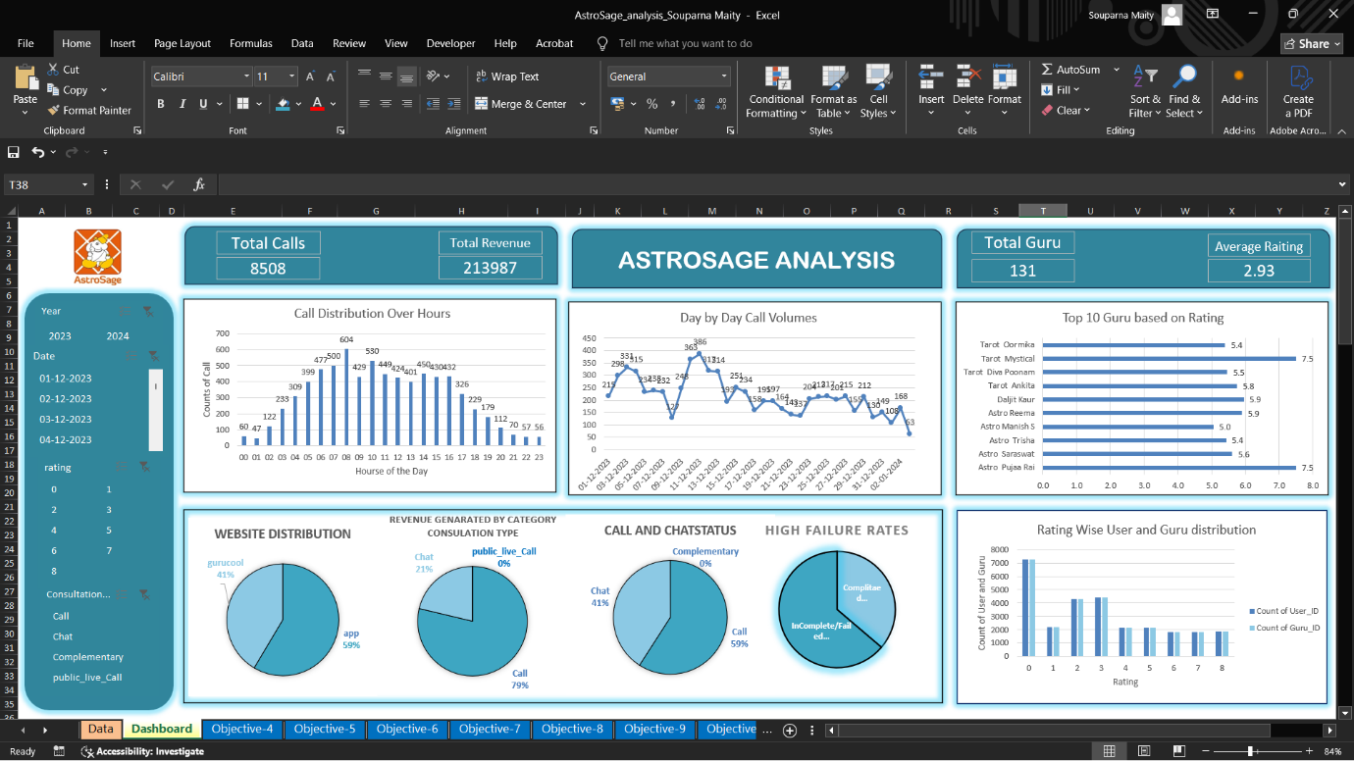
Metrics that are included in Dashboard-
1) KPI (Key performance indicator) – 1. Total revenue.
2. Total Calls
3. Total Gurus
4. Average Rating

2) Changes in call volume day by day- The chart will shows changes in average call volume day by day.
3) Hour vs Count of calls (Hourly active user)– It will show the numbers of call during different hour in day.
4) Top 10 rated gurus Based on their Earning.
5) Revenue Genarated by Category Conclution Type – Pie Chart
6) Call Status and Chat Status – Pie Chart
7) Rating wise User and Guru Distribution
8) Guru distribution by rating.
Slicer (Filter)- 1. Consultancy type.
2. Rating

10) How would you allocate a 1 crore rupee investment to optimize operational
efficiency, enhance customer satisfaction, and boost profitability, and what
analysis-based recommendations would you offer to support this?
[you have to give bullet pointers in order to answer this question]

To maximize the impact of the ₹1 crore investment, the fund is strategically allocated based on performance data, operational gaps, customer satisfaction scores, and consultation success rates.

40% – Technology Upgrades (₹40 Lakhs)
Invest in intelligent call routing, real-time dashboards, and automation tools.
Why: Enhances operational efficiency, reduces manual errors, and improves customer wait times—key drivers of satisfaction and revenue.

30% – Agent Training Programs (₹30 Lakhs)
Structured learning modules focused on communication, product knowledge, and customer handling.
Why: Over 50% of agents rated below 4/10; upskilling is critical to boost consultation success and retention.

20% – Hiring Specialized Agents (₹20 Lakhs)
Onboard experienced agents with domain expertise for high-value consultations.
Why: Reduces the number of incomplete/failed calls (currently 58.74%), increases conversion, and balances workload

10% – Marketing & Advertisements
An allocation of ₹10 lakhs from the investment budget should be directed toward strengthening the brand presence and enhancing customer engagement. This can be achieved through targeted marketing campaigns, digital promotions, and strategic partnerships to position AstroSage ahead of its competitors. Additionally, collecting customer feedback through surveys and reviews will help refine marketing strategies, improve service offerings, and increase user trust and platform adoption.

Analysis-Based Justification
Call Volume Imbalance: Some agents handle a disproportionate share of calls; leads to burnout and lower service quality.
Customer Satisfaction: Average ratings mostly range between 3–4.5; indicates scope for improving agent engagement and consultation effectiveness.
Consultation Completion Rate: Only ~32% of calls result in completed consultations—signaling high drop-off and missed revenue opportunities.
Revenue Dependency on Calls: Calls are the primary revenue driver; declining volume and low ratings impact profitability.
Operational Cost Sensitivity: Investing in tech and skilled manpower can yield higher ROI by improving consultation quality and sales conversions.

Thank You

